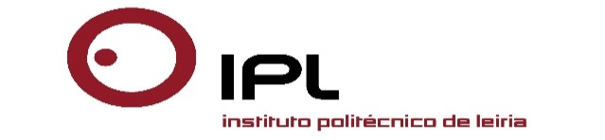

INTERNATIONAL WEEK 02-06 May 2016

‘Changing Governance in Higher Education- Collaborative Working´

POLYTECHNIC INSTITUTE OF LEIRIA

Application form

Please, return this form before April 15th 2016 to
acecilia@ipleiria.pt

☐ Ms ☐ Mr

Name: __________________________ First Name: ___________________
Institution: _______________________________________________________
Function: _______________________________________________________
Address: _________________________________________________________
Postal Code / City / Country: _________________________________________
Tel.: ____________________________ Fax: _________________________
E-mail: __________________________________________________________

Workshop: Changing Governance in Higher Education- Collaborative Working ☐
Networking Exhibit ☐
Special requirements:
______________________________________________________________

______________________________________________________________

Accommodation:

Teacher’s Residence Hall ☐
Hotel S. Luís ☐

Social Programme

Port Wine Reception ☐

Bus Trip – Touristic Locations in the District ☐

Barbecue Dinner ☐

International Dinner ☐

