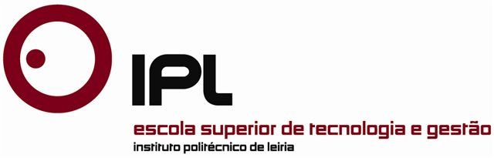

Dissertation /Project Report/Internship Report
Master in ……

Title

Name of the Candidate

Leiria, Month…of year…

This page was intetionally left blank

Dissertation/Project Report/Internship Report
Master in ……

Title

Name of the Candidate

Dissertation/Report developed under the supervision of Doctor… name of supervisor, professor at the School of Technology and Management of the Polytechnic Institute of Leiria and co-supervision of Doctor … name of co-supervisor…. , professor at the School of Technology and Management of the Polytechnic Institute of Leiria.

Leiria, Month…of year…

This page was intetionally left blank

Dedication (optional)

This page was intetionally left blank

Acknowledgements (optional)

This page was intetionally left blank

Resumo (in Portuguese)

Palavras-chave: (máximo 6 palavras)

This page was intetionally left blank

Abstract

Keywords: (6 words maximum)

This page was intetionally left blank

List of figures

This page was intetionally left blank

List of tables

This page was intetionally left blank

List of acronyms

This page was intetionally left blank

Table of Contents
Dedication (optional) iv
Acknowledgements (optional) vi
Resumo viii
Abstract x
List of figures xii
List of tables xiv
List of acronyms xvi
Table of Contents xviii
1. Chapter Title 1
1.1. Section Title 1
1.1.1. Subsection Title 1
References 3
Appendices 5
Glossary 7

- Chapter Title

  - Section Title

    - Subsection Title

References

This page was intetionally left blank

Appendices

This page was intetionally left blank

Glossary

